**Creating a Dev Scratch Org**

CCI: https://cumulusci.readthedocs.io/en/latest/get_started.html

1. Open GitHub Desktop
2. Click File – Clone Repository
3. Find the UST-EASY, then click Clone.
4. Now switch to IntelliJ
5. File – Open – and find the folder where we cloned the repository, then click Ok.

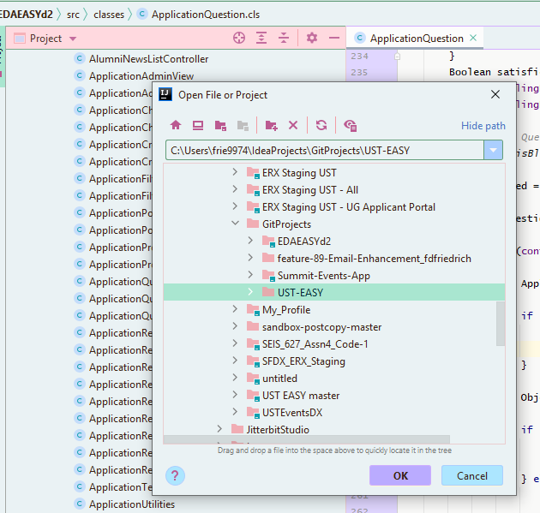

1. Ignore any errors for now.
2. Open the IntelliJ Terminal

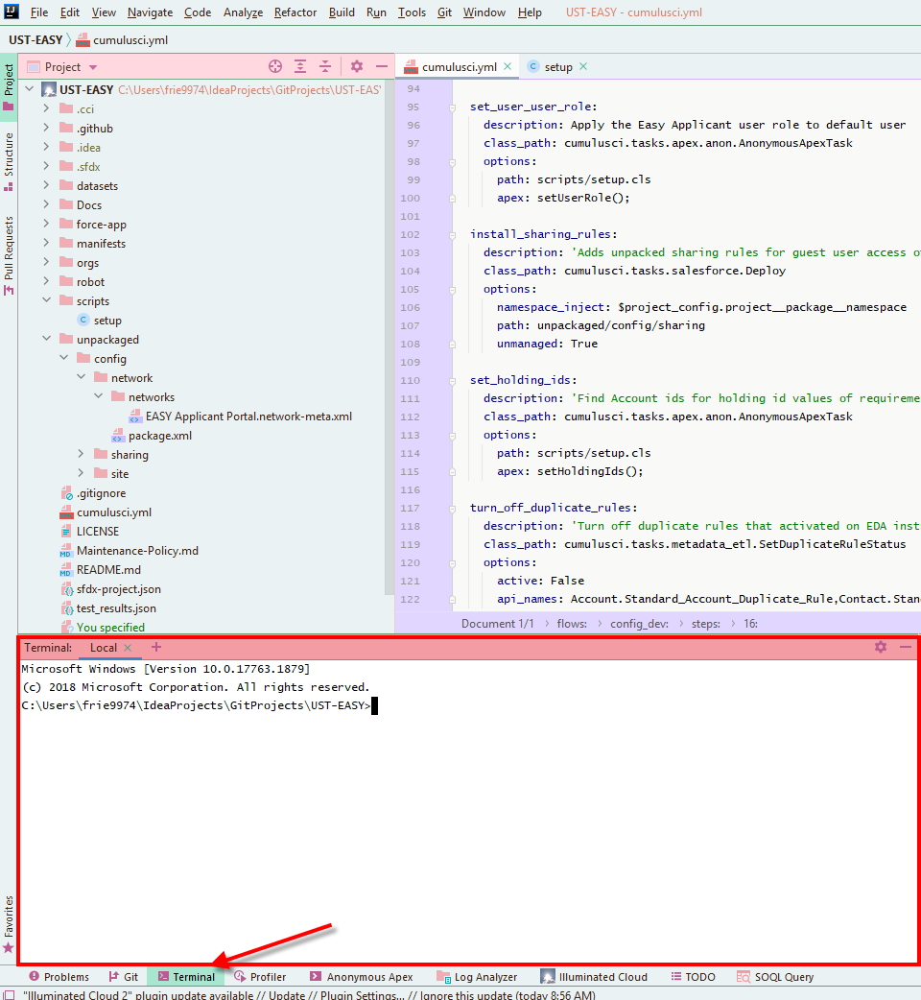

* 1. Altnernate: Use Windows cmd
     1. Windows+R to open a run box
     2. Type “cmd” in the box, and click enter

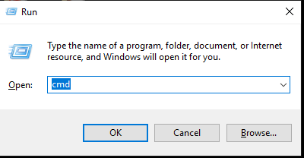

* + 1. Navigate to your directory (cd IdeaProjects\GitProjects\UST-EASY)

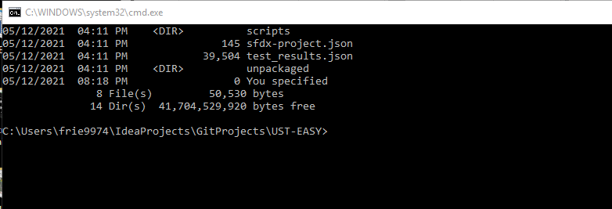

* + 1. Now you can proceed with the remaining instructions using Windows cmd instead of IntelliJ

1. Verify the org structure: cci org list
2. Verify the orgs look similar:

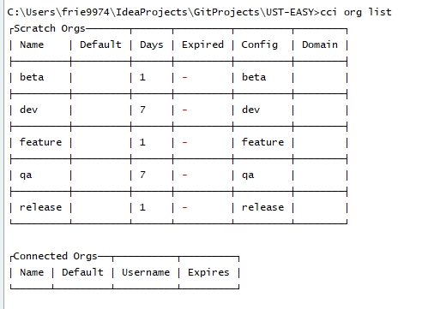

1. Set dev as the default org: cci org default dev
2. Enable dev hub: sfdx force:auth:web:login --setdefaultdevhubusername --setalias my-hub-org
3. A browser window will open. Log into Salesforce EDA Production, then close or minimize the browser window.
4. Create the scratch org: cci flow run dev_org
   1. If you run into an issue and need to start over: cci org remove dev
5. Open the scratch org: cci org browser
6. Once in the Salesforce org, navigate to Setup - Login Flows
7. Click New, and set it up like this:

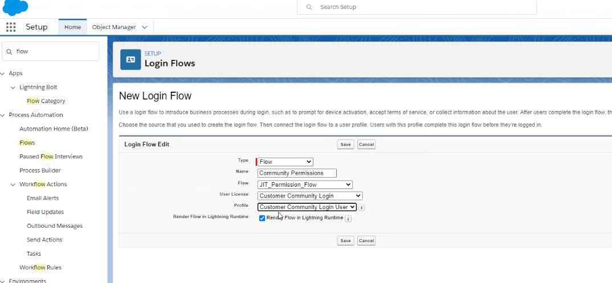

1. Next, you need to finish the community setup. Go to the Community Site, Administration, Login & Registration, and set Account to Applicant Parent Account.
2. Optional: Setup State & Country picklists – run the scan, then convert them all
   1. Note: this takes a lot of time. You only need to set these up if you will be using them.
3. Copy the site URL that was created & update your browser bookmarks for testing/accessing later (in incognito mode)
4. Some commands that will be helpful as you are working in your scratch org:
   1. See changes: cci task run list_changes
      1. Cci task run list_changes –excude Profile
   2. Get changes to git: cci task run retrieve_changes
      1. Can also exclude something with –exclude
   3. Push changes: git status, which will open github desktop, then update your notes about change and commit to master (or to your own branch).
   4. Push changes to scratch org: cci task run dx_push
   5. To delete an org: cci org remove dev
   6. To add checklist to a page:

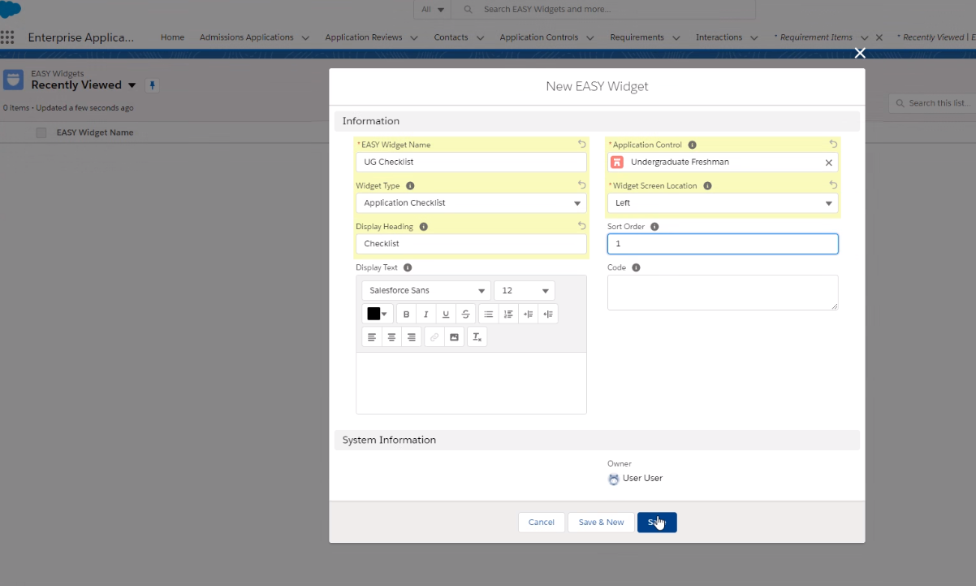

1. List of CCI Commands (from Open Source Sprint CCI training):
   1. Upgrade CCI: pipx upgrade cumulusci
   2. CCI Service list
   3. pipx upgrade cumulusci
   4. cci version
   5. cci org browser dev
   6. dev org username: farrah.friedrich_mydev@stthomas.edu
   7. sfdx force:auth:web:login --setdefaultdevhubusername --setalias my-hub-org
   8. cci org default dev
   9. cci org list (to verify that it is set as org)
   10. cci task run list_changes --org dev
   11. cci task run list_changes --org dev -o exclude "Profile:"
   12. cci task run retrieve_changes --org dev -o exclude "Profile:"
   13. cci flow run qa_org --org dev
   14. cci task run generate_dataset_mapping --org dev
   15. cci task run extract_dataset -o database_url "" -o mapping datasets\generated_mapping.yml -o sql_path datasets\test_data.sql --org dev
   16. CCI Commands to create an org:
       1. cci update
       2. sfdx update
       3. check branch: git branch
       4. cci org list
       5. cci org default dev
       6. cci flow run dev_org